Problem statement:
Develop a web-based interactive 3D visualization platform that integrates numerical ocean model outputs and in-situ observations.
Explanation:
India's ocean agency (INCOIS) has two kinds of ocean data — computer predictions (models) and real measurements from floating robot sensors (Argo floats, Gliders). Right now, there's no single website where you can see both together in 3D. Scientists use different tools, and most only show flat 2D maps, not real depth.
What Needs to Be Built:
A website (works in any browser, no download needed) that:
- Shows the ocean in true 3D — you can rotate, zoom, and see different depths
- Shows sensor locations as clickable dots — click one to see a graph of temperature/salinity at that spot
- Lets users switch between variables (temperature, salinity, currents), slide through depth, and animate through time
- Can be expanded later to add new sensors or data types
Existing Solutions Summary:
Yes, existing solutions are available, such as:
Copernicus Marine / MyOcean Pro – Web-based ocean data visualization.
MyOcean Learn – Simple 2D/3D ocean data exploration.
Ocean Data View (ODV) – Scientific tool for analysing ocean observations.
INCOIS systems – Already provide ocean models and observation data.
Main problems with existing solutions
Data is not fully integrated – Model data and real instrument observations may not be shown together smoothly.
Model vs real-data comparison is limited – Comparing a model value with an Argo/Glider observation at the same depth, location and time is not the main workflow.
Some tools are desktop-based – They may require software installation.
Not specifically designed for INCOIS – Existing platforms are general-purpose.
Complex for some users – Scientific tools can require technical knowledge.
Different data sources/tools – Scientists may need multiple systems for different datasets.
🎯 Our opportunity
We should not say "no existing solution exists."
Instead:
“Existing platforms visualize ocean data, but our solution will provide one simple, browser-based 3D platform focused on INCOIS that combines model data + real observations and makes their comparison easy.”
Our main USP:
🌊 3D Ocean + Model Data + Argo/Glider Observations + Easy Comparison — all in one place.
Technical Approach:
Technology Stack Summary
Layer | Technology
3D Rendering | Three.js / Cesium.js (WebGL)
Frontend UI | React
Charts | Chart.js / D3.js
Backend API | Python FastAPI
Data Parsing | xarray, netCDF4, pandas
Data Serving | REST + OPeNDAP
Standards | OGC WMS/WCS, CF Conventions
Hosting | Cloud/on-prem server (INCOIS infra)
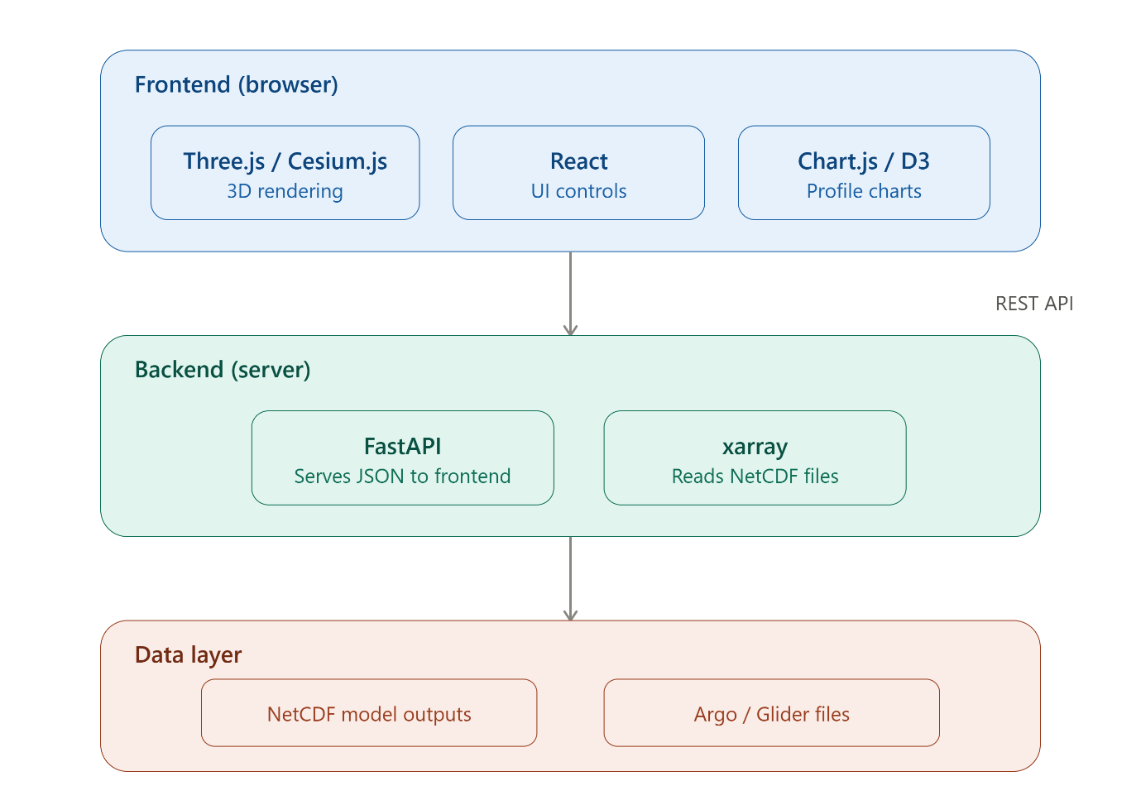
🌊 SIH26067 — Our Solution in Short
What we build:
A 3D Ocean Digital Twin in a web browser.
Basic features:
🌍 Interactive 3D ocean
🌡️ Temperature
🧂 Salinity
🌊 Currents
⬇️ Depth navigation
⏱️ Time animation
📍 Argo, Glider and other observations
📊 Graphs/profiles
⭐ Our unique features:
Model vs Observation
Compare computer prediction with actual instrument measurement.
3D Difference Field
Show exactly where the model is over/under-predicting.
Automatic Anomaly Detection
Find unusual differences automatically and highlight them.
Model Health Score
Give an overall performance score for the model.
Observation Coverage
Show regions where real observations are sufficient or lacking.
AI Ocean Assistant
User can ask questions like:
“Where is the largest temperature difference?”
and the system finds and explains it.
🏆 Our USP
Existing platforms mainly help users VIEW ocean data. Our platform helps users UNDERSTAND and ANALYZE the difference between predicted and real ocean conditions.
Our core flow:
3D Ocean → Model Data + Real Observations → Compare → Detect Difference → Identify Anomaly → AI Explanation

